Week 2 - DevOps Masterclass
Deploy a static site via GitHub → VM → Nginx

Objective: Create a public web endpoint that serves a provided index.html using Nginx on a cloud VM, with the file sourced from a GitHub repository.

Steps
Setup a VM
Connect to the VM
Install a web server software on the VM. This turns a VM into a web server
Install a git software on the VM to download the artefact
Use git to download artefact to the web server html directory
start/ restart web server
Open port 80/http
Test to check/ ensure website is up.

1. GitHub repo
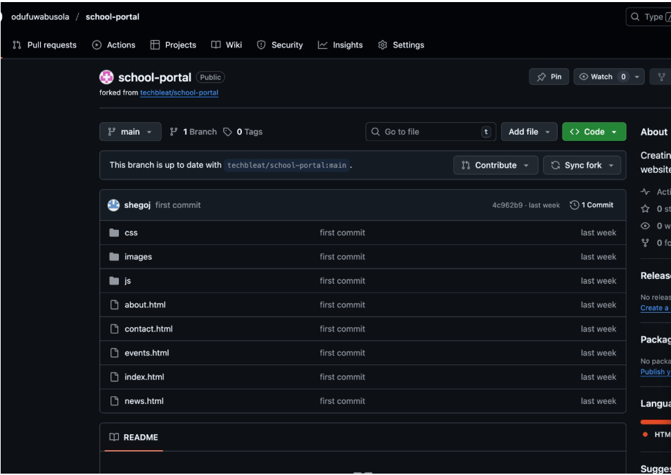
- Create a new GitHub repository (public)
https://github.com/odufuwabusola/School_portal.git

- Add index.html at the repo root and push it.

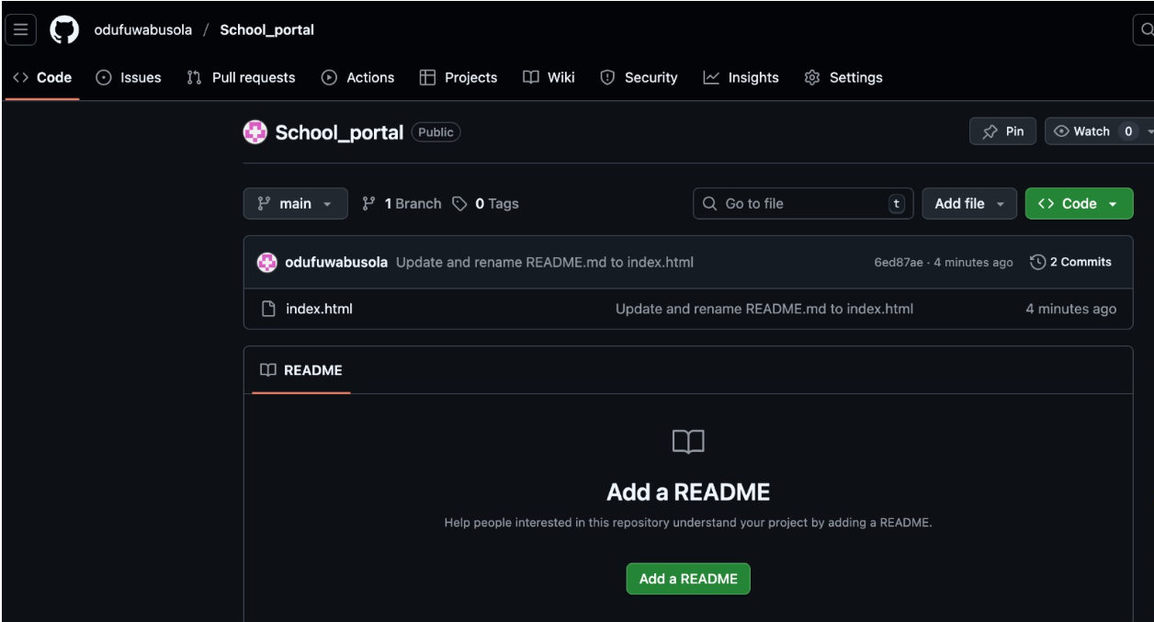

Cloud VM (AWS)
Linux VM (e.g., Amazon-Linux/Ubuntu 22.04) with inbound HTTP (80) open.
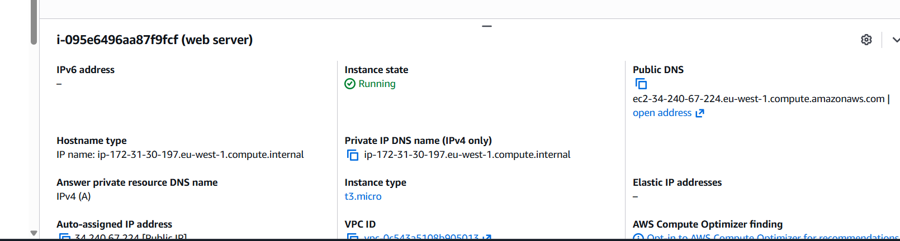

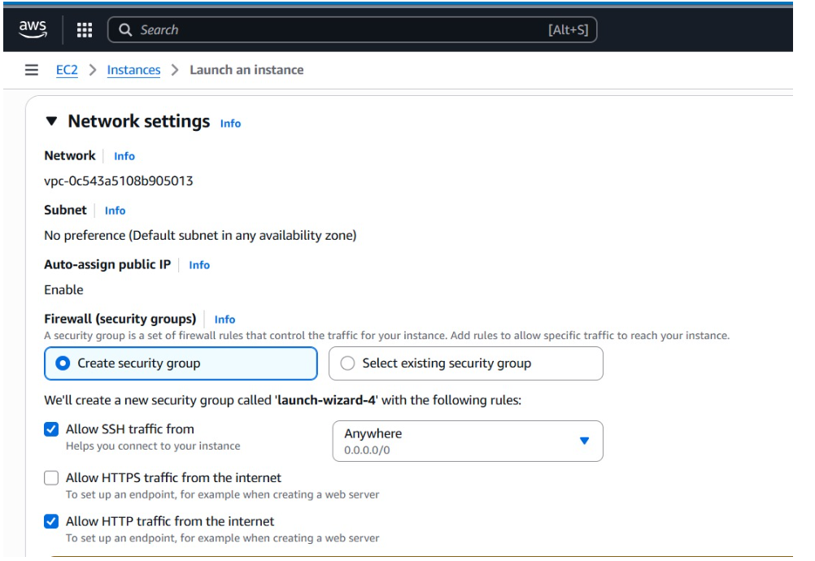

VM’s public IP or DNS. ec2-34-240-67-224.eu-west-1.compute.amazonaws.com
ec2-52-215-222-140.eu-west-1.compute.amazonaws.com

Retrieve site via Git
- SSH into the VM, install Git, and clone the repository to the VM.
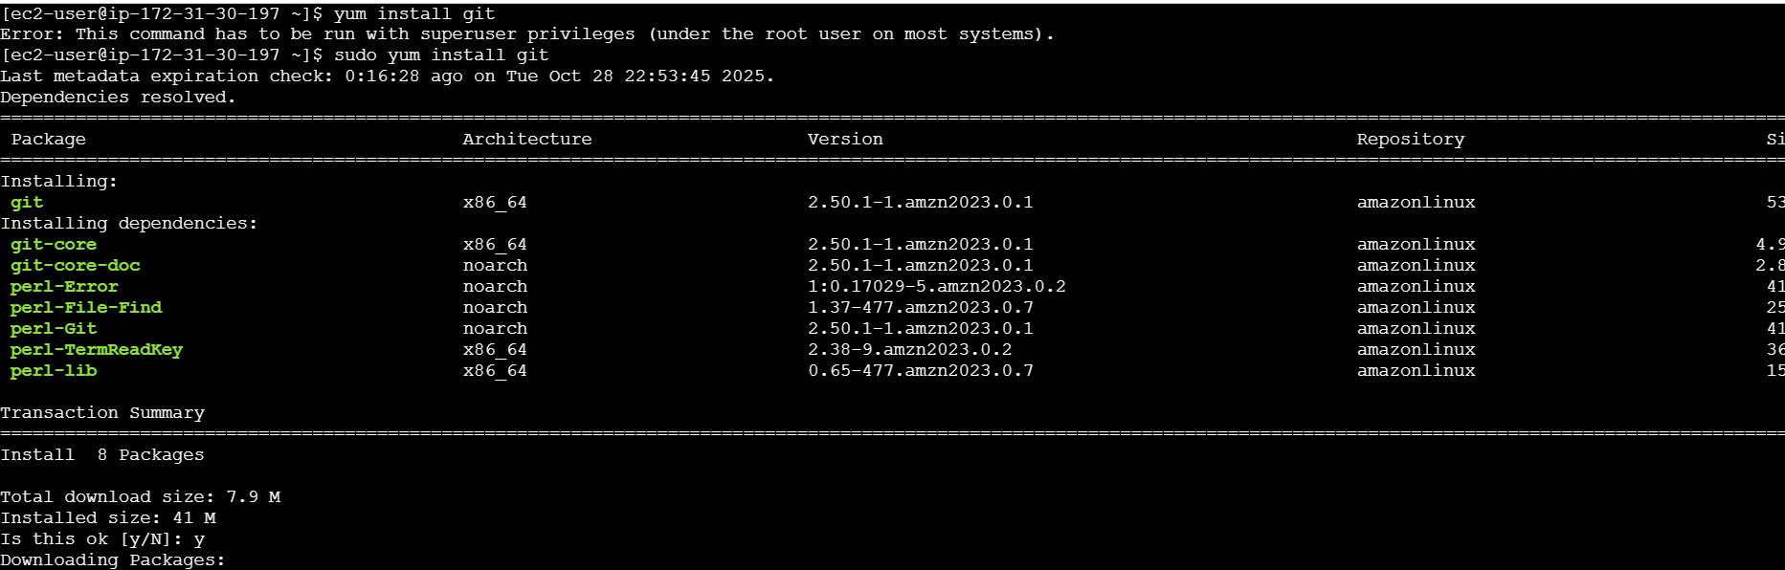

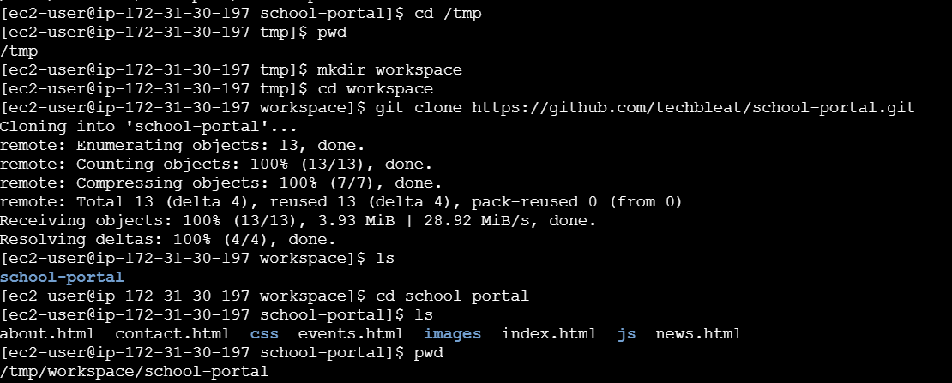

Install & configure Nginx
- Install Nginx.
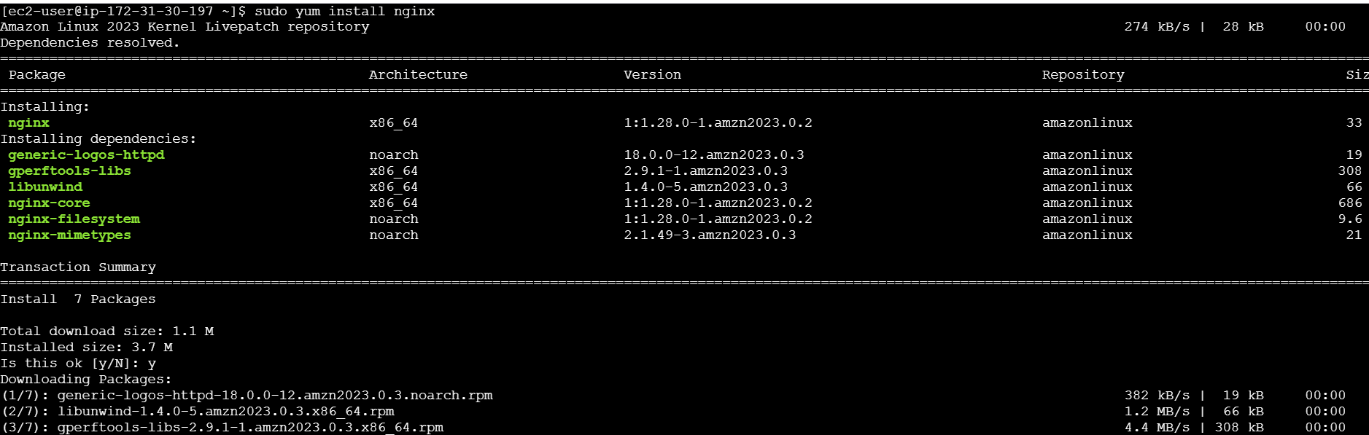
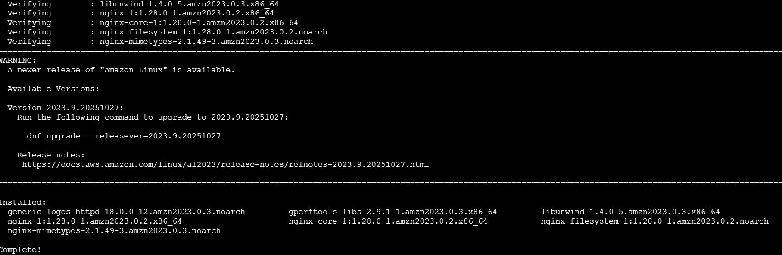

- index.html in Nginx’s web root

- Start/enable Nginx and verify it serves index.html.
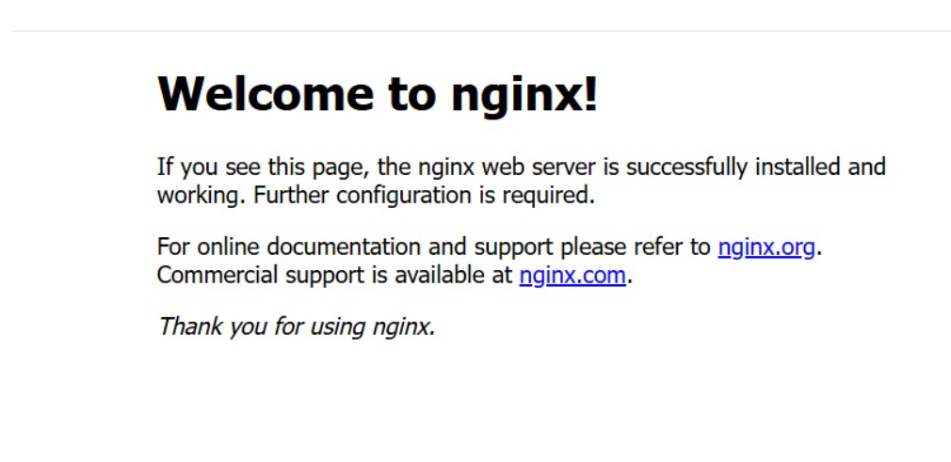
Verify the portal load
- Access the VM’s public IP/DNS over HTTP and confirm the page loads.
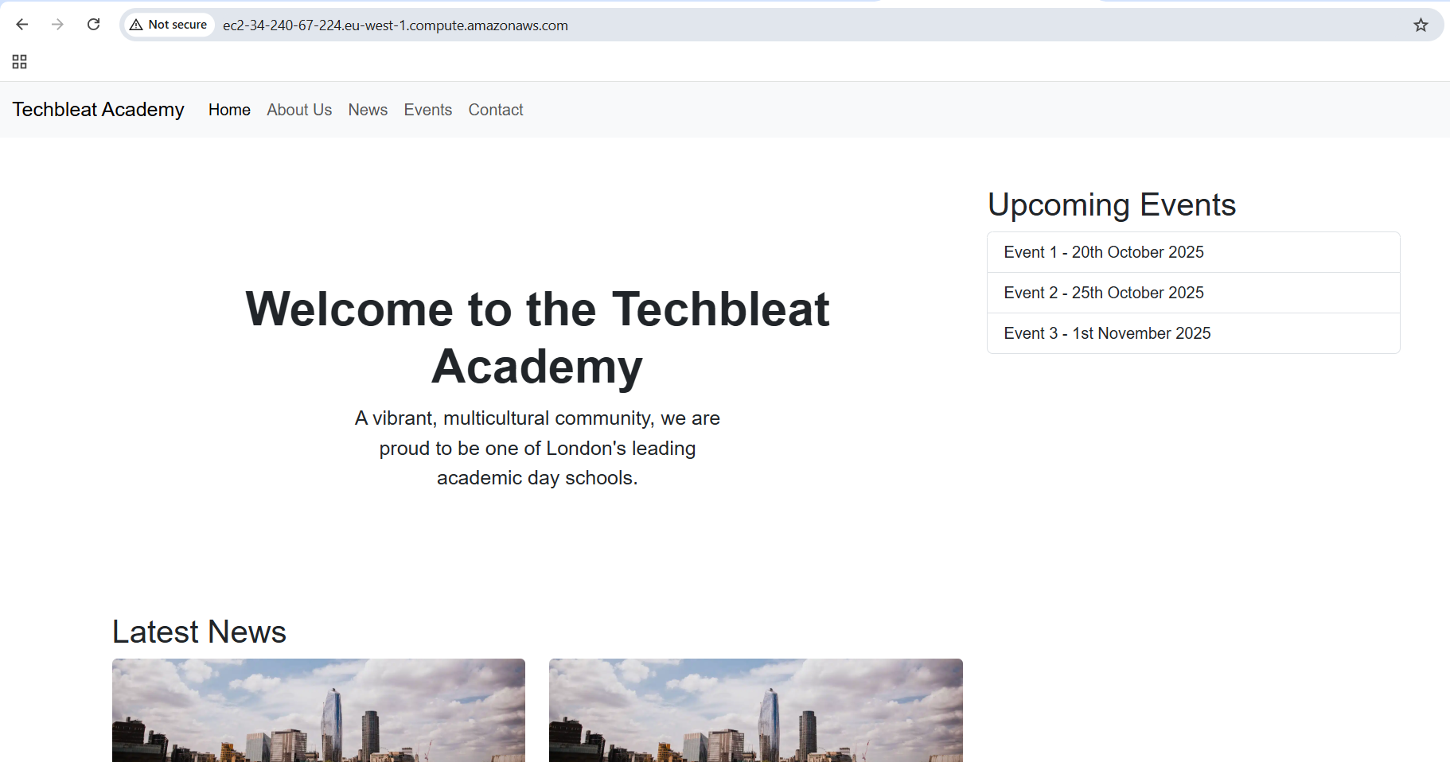
- URL: http://ec2-34-240-67-224.eu-west-1.compute.amazonaws.com

- Commands used.
